**Final individual project**

**Part A. Character relations**

Moretti (2011) examines the use of network analysis to comprehend the links and interconnections between characters in novels in his article "*Network Theory, Plot Analysis*". For *Hamlet* and *The Story of the Stone*, he provides a visual summary of the network of characters, which depicts the relationships between the characters as lines on a network.

The fact that this visual summary (Graph 1) gives a clear and succinct understanding of the relationships between the characters in *Bonita Avenue* is one of its advantages. The visual summary makes it simple to identify which characters are connected to one another and to comprehend the patterns and trends in their interactions by representing these relationships as lines on a grid.

The great advantage of Graph 1 is when we talk about a character in *Bonita Avenue,* it is no longer an abstract literary theory, but automatically turns to 'consciousness' and 'interiority' (Moretti, 2011). Specifically, firstly,centrality. We can judge the centrality of Aaron Bever, Siem Sigerius and Joni Sigerius by the position of the characters. In other words, Aaron Bever, Siem Sigerius and Joni Sigerius are the typical characters in the novel. Secondly,clustering. The triangle formed by Aaron Bever, Siem Sigerius and Joni Sigerius which is the densest part of the whole network.Almost everyone in the network is associated with them and the clustering is almost 100%. Lastly, plot. According to the sparseness of the lines between the different characters, that is, the complexity of their interactions, we can infer the direction of the novel's plot. Moreover，we can conclude that the number of male characters is roughly the same as the number of female characters based on the legends, with slightly more males.

This graphic explanation does have certain drawbacks, though. For instance, it offers no details regarding the nature of the relationships between individuals. Therefore, beyond the relative strength of the associations, this visual network analysis offers no information about the nature of the links between the characters. For instance, it is clear that there is a strong connection between Aaron Bever and Siem Sigerius, but it is impossible to determine if this bond is friendly or hostile.

Additionally, as was already indicated, a network analysis of this kind cannot adequately capture the complexities of the character associations, and as a result, crucial details may be lost when they are summarized. Examples include the particular events and interactions that shaped these connections. Such a visual network analysis might exclude certain potentially intriguing but subtle connections by concentrating exclusively on the most crucial or central character interactions.

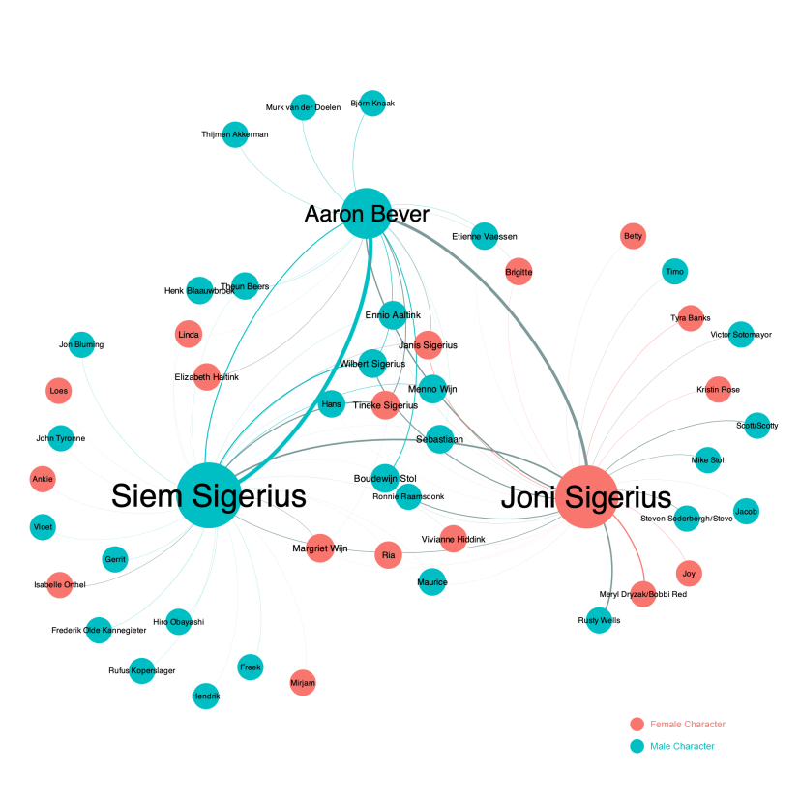

Graph 1: Network Analysis of relationships among characters in Bonita Avenue

Part B

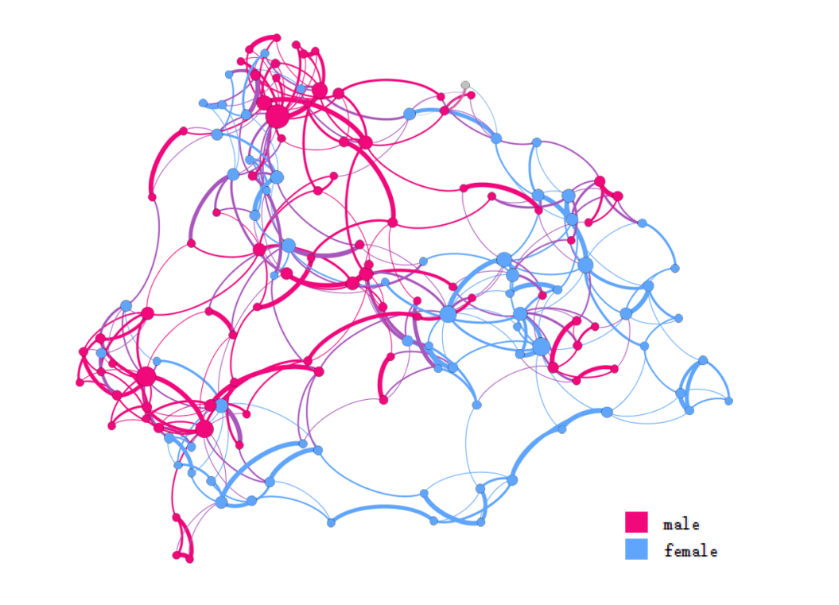

Graph 2: Network Analysis of relationships among British novels between 1771 and 1930 categorised by gender

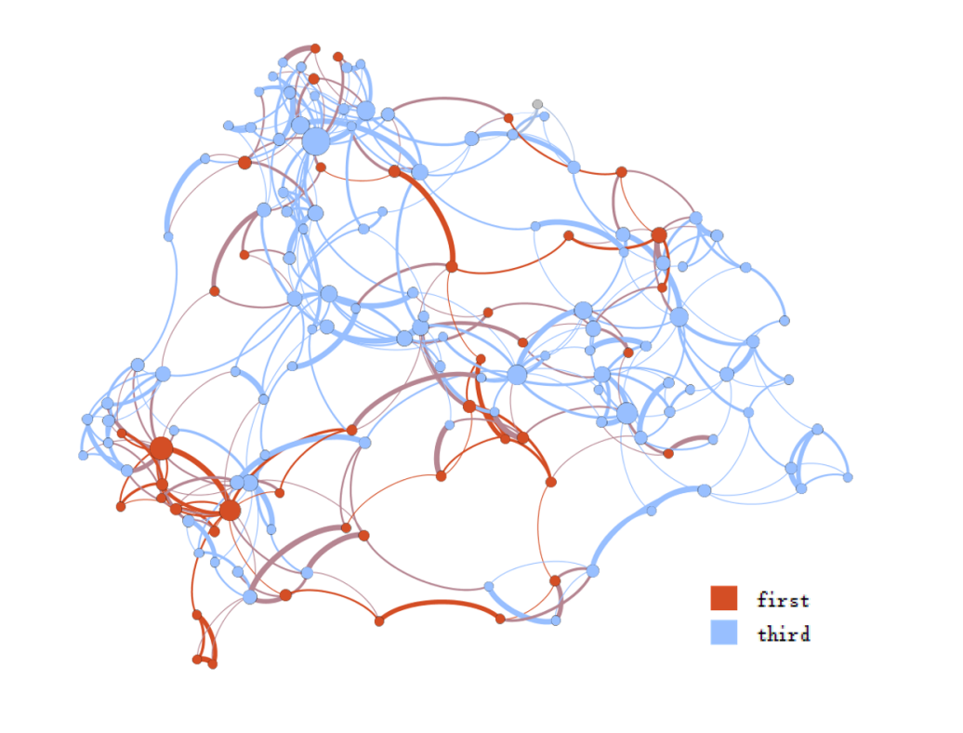

Graph 3: Network Analysis of relationships among British novels between 1771 and 1930 categorised by narrative perspective

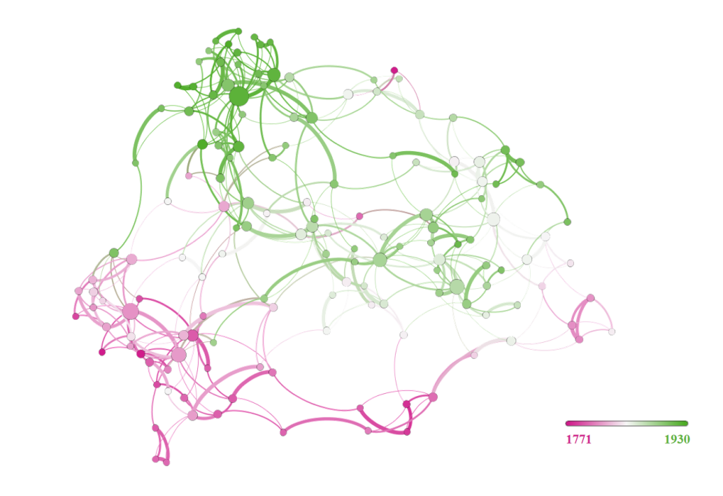

Graph 4: Network Analysis of relationships among British novels between 1771 and 1930 categorised by year

Graph 2 and 3 indicates the network of relationships among British novels between 1771 and 1930 categorized by gender and narrative perspective respectively. In Graph 2, male and female writers are mixed with no clear boundaries. This shows that there is no clear difference in style between novels written by male and novels written by female. The situation in Graph 3 is the same as that in Graph 2. There is not much difference in style between novels with the first-person narrative perspective and those with the third-person narrative perspective.

In Graph 4, the two clusters are mainly found in the periods around 1771 and 1930, which means that among the 150 British novels, novels published around 1771 and 1930 occupy a central position in the network and have a high degree of stylistic similarity. The year 1771 coincided with the transition from classicism to Enlightenment, during which the Enlightenment broke out. Enlightenment novels aimed at enlightening the masses competed, and such novels emerged to create public opinion for the bourgeois revolution of the time. 1930 was in the period of modernism for the Western novel. The turbulent 20th century plunged the whole world into a crisis of thought and spirit. Modernist fiction rose rapidly, and it parted ways with realism to become an anti-realist literary trend. This explains, in part, the high degree of stylistic similarity between the novels published around 1771 and around 1930.

Generally speaking, the writing style of the same author is always similar, and novels on the same topic will have high stylistic similarity because they often use the same lexical resources. So, do the novels with high stylistic similarity in Figure 4 come from the same person? Are they on the same topic? Because Figure 4 only provides information on the year, without information on the author, gender, and subject matter, the answers to these questions are unknown to us and need to be further explored.

**Reference**

Franco Moretti, ‘Network Theory, Plot Analysis’. *New Left Review* 68 (2011): 80-102.